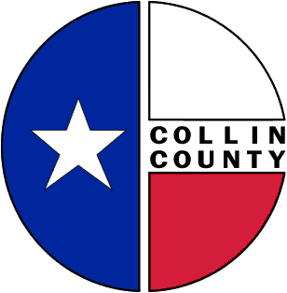 | COLLIN COUNTY | Engineering Department  825 N. McDonald Street  Suite 160  McKinney, Texas 75069  972-548-3727  www.collincountytx.gov

To: Commissioners Court Date: 1/22/09

From: Ruben Delgado, P.E.
Director of Engineering

Subject: Request for Approval of Interlocal Agreement Between Collin County and the City of Frisco for Bond Project #03-069 for Improvements to Independence Parkway from SH 121 to Main Street

Attached are Interlocal Agreements from the City of Frisco requesting approval for funding of improvements to Independence Parkway from SH 121 to Main Street.

Funding for this project was approved by Commissioners Court on May 30, 2006 with the reallocation of funds from Bond Project #03-021 (FM 3537 from SH 289 to FM 2478) – see attached Court Order No. 2006-500-05-30.

We request Commissioners Court favorably consider approval of the attached ILA between the Collin County and the City of Frisco and further request authorization for County Judge Keith Self to execute the ILA.

xc: Bill Bilyeu, Administrative Services
Monika Aires, Budget Office
Tracy Homfeld

MD/:FRISCOILABONDPROJECTNO.03-069INDEPENDENCE

