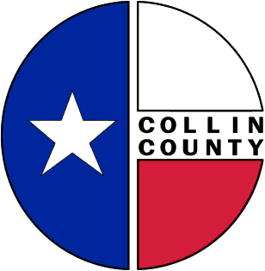 | COLLIN COUNTY | Engineering Department  825 N. McDonald Street  Suite 160  McKinney, Texas 75069  972-548-3727  www.collincountytx.gov

To: Commissioners Court Date: 3/22/06

From: Ruben Delgado, P.E.
Director of Engineering

Subject: Request for Approval of Interlocal Agreement Between Collin County and the City of Plano for Bond Project #03-059 for Improvements to Independence Parkway from McDermott Road to SH 121

The City of Plano requests Commissioners Court approval for the attached Interlocal Agreement for the widening of Independence Parkway from McDermott Road to SH 121. The project will consist of widening Independence Parkway from four to six lanes for a distance of approximately 6,000 feet.

We request Commissioners Court favorably consider approval of the attached ILA and request authorization for County Judge Keith Self to execute the ILA.

xc: Bill Bilyeu, Administrative Services
Monika Aires, Budget Office
Tracy Homfeld

MD/Plano Bond Project No. 03-059 Independence Parkway

