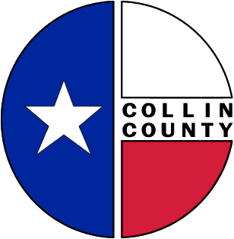 | COLLIN COUNTY | Construction & Projects  4600 Community Ave.  McKinney, Texas 75071  Phone: 972-547-5340  FAX: 972-547-5385

To: Commissioners’ Court
From: Bill Burke/Director of Building Projects
Date: February 19, 2009
Subject: Award – Professional Services, MEP Engineer for County Projects

Request Commissioners’ Court consideration and approval to award: Professional Services, Mechanical, Electrical, and Plumbing Engineer for County Projects. RFQ No. 11236-09 to the most qualified bidder.
Thank you,
Bill Burke
Director of Building Projects

