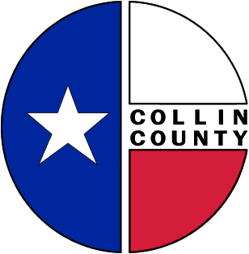 | COLLIN COUNTY | Engineering  825 N. McDonald  Suite 160  McKinney, Texas 75069  972-548-3727  www.collincountytx.gov

February 19, 2009

TO: Judge Self and Commissioners

FROM: Ruben Delgado, P.E., Director of Engineering

RE: Collin County Parks and Open Space Project Funding Assistance Program
2007 Bond – First Series, $2.4 million

On behalf of the Parks Foundation Advisory Board, we are seeking approval from Commissioners Court of the following schedule for the Project Funding Assistance Program:

Thursday, March 12, 2009 Seek Commissioners Court approval of timeline

Monday, March 16, 2009 Mail Application Packet

Tuesday, July 7, 2009 Application Submittal Deadline (close of business)

Thursday, July 9, 2009 Applications provided to Parks Foundation Advisory Board for review

August – September Review by Parks Foundation Advisory Board

October 2009 Submit Funding Recommendations to Commissioners Court

We will be available to answer any questions you might have regarding this matter.

cc: Bill Bilyeu
Jeff Durham

