JUSTICE ASSISTANCE GRANT (JAG)
Addendum

Submission Instructions: email to cjapplications@nctcog.org by June 1, 2009
COMPLETED ADDENDUM SHOULD NOT EXCEED 5 PAGES

Agency Name: Collin County Sheriffs Office
Application title:
Application #:

Individual Project Title (if applicable): Unmanned Aerial Vehicles

PROJECT BUDGET INFORMATION – indicate the total amount of each line item for this project:

CATEGORY | REQUESTED AMOUNT
Personnel | $0
Contract & Professional Services | $0
Travel & Training | $20,000
Equipment | $210,000
Supplies & Direct Operating Expenses | 5,000
Indirect | $0
TOTAL FOR THIS PROJECT | $235,000

1. PROBLEM STATEMENT AND SUPPORTING DATA (up to 15 points): The problem statement should refer to situations outside of your organization that are directly related to your target population. What “external” situation will be dealt with if you are awarded the grant? Substantiate the problem by providing at least two years of data that are relevant to the target area served. NOTE: Data source(s) must be noted and verifiable.

Collin County covers approximately 890 square miles of rural, semi-rural and urban development. The 2009 population estimate for Collin County is 764,500 per the North Central Texas Council of Governments. Four of the top ten growing cities of the Metroplex are in Collin County.

A major problem for the law enforcement agencies in Collin County is that there are no air support capabilities within the County. The closest air support for Collin County is Dallas Police Department or the Texas Department of Public Safety. Both have helicopters but are generally only available for emergency purposes. Within the last two years, the Collin County Sheriff’s Office has requested air support from either Dallas PD or DPS on numerous occasions for problems such as fugitives at large, drownings, and missing children. In some of the cases either DPD or DPS was able to respond, but only after a lengthy delay. There were numerous other incidents that would have benefited by air surveillance. These include major crowd gatherings, pursuits, narcotics surveillance, illegal dumping, tactical support, and natural disasters. As can be seen in the below graph, the calls for service within Collin County continue to grow as the population increases.

Above statistics provided by each individual agency.

The problem, as stated above, is air support. The solution is not an expensive helicopter but six strategically placed unmanned aerial vehicles (UAV) that would enable the Collin County Sheriffs Office and other Collin County law enforcement agencies to bring real time and accurate air surveillance video to officers on the scene in a timely, cost effective manner.

2. GOAL STATEMENT (40 WORDS OR LESS) (up to 5 points): Describe the goal of the project as it relates to the identified problem(s). Proposed project goals are clearly stated and reflect anticipated outcomes of the project. The goal is all about the target group and how they will be changed/improved/impacted. Goals must be attainable within the grant period. DO NOT include statistical data or activities in the goal statement.

The project goal is to provide the 23+ law enforcement agencies of Collin County with air support necessary to search and identify problems over a broad area in a timely manner, resulting in increased safety to the officers and citizens

- PROJECT DESCRIPTION (up to 20 points):

ALL PROJECTS: Completely describe those activities and the strategies to be used to respond to the needs of your target population. It should be clear that the activities/strategies are in direct response to the problem.

EQUIPMENT ONLY: Describe how this equipment will be used: What does the equipment do? Who will use it? What training, if any, will be needed in order to implement this equipment? How often will the equipment be used? Describe the sequence of events/activities that will typically take place when your agency uses this equipment.

Helicopter programs have traditionally been used in law enforcement to conduct searches, monitor mass gatherings, gather intelligence, respond to man made and natural disasters, Hazmat events, illegal dumping, and various other uses. Helicopters are expensive to buy (1 to 2 million dollars each) and expensive to maintain (approximately $500,000 per year) and require highly trained pilots. New advances in Unmanned Aerial Vehicles (UAV) that have been adapted to law enforcement support have brought the cost for air support down to very affordable levels. Non pilots can be trained to fly UAVs in a very short period at very low cost. Collin County proposes that six UAVs be purchased and stored at various law enforcement agencies throughout the County and a number of law enforcement personnel from these agencies be trained in their operation. This will allow rapid deployment whenever and wherever air support is needed.

The UAVs would be transported to the areas of use. These UAVs are quite small (see pictures) and very light weight.

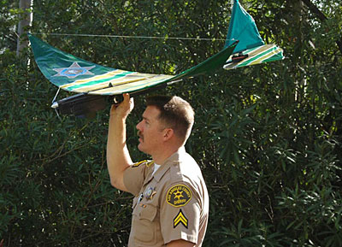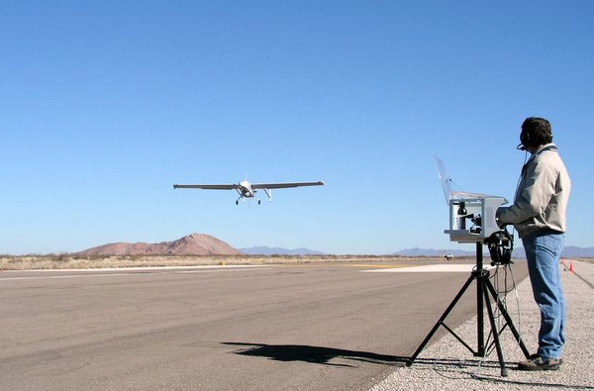

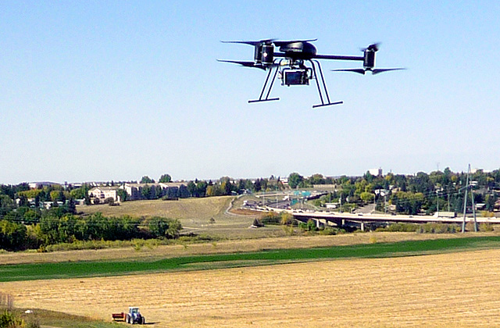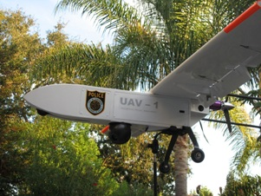

They may be launched by one person. The UAVs will carry a gyro-stabilized camera and may remain aloft for over 1 hour depending on the payload. Once launched the operation would then be supported from a nearby command post by trained personnel. From this vantage point real time video transmissions would prove invaluable to deputies and officers on the ground involved in the operation. Real-time decisions could be made that would have immediate impact on the result of the event, safety of the officers, citizens involved, as well as the general public. This project is cost effective in that it provides the same benefits and results of a helicopter at a greatly reduced overall cost. The UAV requested is similar to those operated by the military but adapted for law enforcement use and cost much less to operate and maintain. The UAVs would be stored and maintained using current existing facilities within Collin County. The UAVs would be operated by existing personnel within the Sheriffs Office or other trained law enforcement personnel. Training would be provided by the UAV vendor.

The ability to have quick, cheap air support will allow any call for service that could benefit from air support to obtain that support. We would expect that 0.1% to 0.5% of all calls could benefit from air support. Based on the numbers shown in the chart above, we would expect a minimum of 519 uses of the UAVs in a single year.

- TARGET POPULATION BENEFIT AND PROGRAM EVALUATION (up to 20 points):

EQUIPMENT ONLY: How does this equipment benefit your agency? How does equipment benefit/impact the community? Describe sustainability plan for equipment – i.e., Long-term maintenance? On-going training? On-going warranty/service contracts? Based on outputs/outcomes in eGrants, describe how you will evaluate this project, including (1) what data will be gathered, (2) how data will be gathered, (3) how outcomes will be measured, (4) the process of data analysis, and (5) how the evaluation will be used for program improvements.

PERSONNEL PROJECT: Describe the anticipated benefits/impact for your target population. Describe sustainability plan for personnel – what happens after the grant period is complete? Based on outputs/outcomes in eGrants, describe how you will evaluate this project, including (1) what data will be gathered, (2) how data will be gathered, (3) how outcomes will be measured, (4) the process of data analysis, and (5) how the evaluation will be used for program improvements.

The law enforcement version of an Unmanned Aerial Vehicle (UAV) would benefit the entire county, including both the citizens and the law enforcement officers. The major police departments within Collin County are in favor of this solution over the expense, maintenance and operation of a helicopter program. All law enforcement agencies within the County will benefit by UAVs providing the same information and capabilities as those of a helicopter in a safe, timely, effective, and cost efficient manner. The major law enforcement agencies of Collin County are committed to the continuing support of UAVs through personnel, facilities, and all related training now and in the future if this project is approved. This will result in the continuation of this program well beyond the grant period.

The program would be sustained by trained personnel already employed by the Collin County Sheriffs Office and/or other law enforcement agencies and any contract personnel that may be required to maintain the equipment. The evaluation of the project would be managed within the guidelines and operating procedures of the Collin County Sheriffs Office using existing methods and our Computer Added Dispatch (CAD) system. The data would include type of call, deployment information such as time to deploy, length of deployment, and the result of the use of the UAV use. Data would be totaled and maintained on a monthly and yearly basis and analyzed regularly by the Major of Field Operations. Based on this analysis the UAVs may be repositioned, provided with additional equipment, or utilized in other situations as required.

- AGENCY COLLABORATION (up to 5 points): In the table below, list up to ten (10) of the most important collaborations that your agency has with other entities in order to carry out this project. All applicants are strongly encouraged to collaborate with other agencies to achieve similar goals. This includes program integration and enhancement activities, and joint funding efforts.

Equipment Only: Describe if the equipment will be shared with other jurisdictions, describe if others outside your agency will be trained in using the equipment, describe any collaborative purchasing agreements.

Agency name | Describe nature of relationship and results the relationship is expected to achieve in carrying out this project.
Frisco Police Department | Letter of Cooperation – Will support the project with personnel,
 | Facilities, and all related training related to the UAV
McKinney Police Department | Letter of Cooperation – Will support the project with personnel,
 | Facilities, and all related training related to the UAV
Allen Police Department | Letter of Cooperation in progress of being approved
Plano Police Department | Letter of Cooperation in progress of being approved
Wylie Police Department | Letter of Cooperation in progress of being approved

- PERSONNEL QUALIFICATIONS (up to 5 points): For grant-funded staff: provide title, indicate new or existing position, name of staff, qualifications of position.

EQUIPMENT ONLY PROJECTS: Who is project manager, role in purchase and implementation? What are qualifications of those using the equipment?

Title | New/Existing Position  (N or E) | Name | PERSONNEL PROJECTS: Qualifications of grant-paid position (not of the person currently in that position)  EQUIPMENT ONLY PROJECTS: Who is project manager, role in purchase and implementation? What are qualifications of those using the equipment?
Project Manager | (E) | C. Ruckel | Major of Field Operations, BS, MS - Management
 |  |  | Will head the committee of Collin County LE
 |  |  | Agencies evaluating and selecting the UAV
Officers | (E) | TBD | Will train on the safe operation and use of UAV. Must
 |  |  | be available when needed and have Patrol
 |  |  | experience

