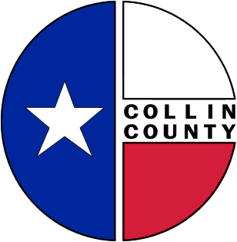 | COLLIN COUNTY | Office of the Purchasing Agent  2300 Bloomdale Road  Suite 3160  McKinney, Texas 75071  www.collincountytx.gov

July 30, 2026

Date: June 9th, 2009

To: Commissioner’s Court
County Judge Keith Self
Commissioner Joe Jaynes
Commissioner Kathy Ward
Commissioner Jerry Hoagland
Commissioner Matt Shaheen

From: Frank Ybarbo
Purchasing Agent

Re: Auction Proceeds

Total proceeds from May 8th, 2009 On-Line Auction $14,014.57
Request Dispersal of Funds as Follows:
$11,300.15-General
$2,714.42-Road and Bridge
Please let me know if you need any additional information.

