COLLIN COUNTY, TEXAS


ADDENDUM No. One (1) IFB NO. 03439-09

INVITATION FOR BIDS
FOR

New Exterior Stairs, 900 Park Plaza Building

DATE: June 29, 2009

NOTICE TO ALL PROSPECTIVE BIDDERS:

YOU ARE HEREBY DIRECTED TO MAKE CHANGES TO THE INVITATION FOR BIDS IN ACCORDANCE WITH THE ATTACHED INFORMATION.

NOTICE: THIS ADDENDUM IS ISSUED BY THE ARCHITECT AND OWNER TO ALL KNOWN INDIVIDUALS, FIRMS OR CORPORATIONS WHO HOLD BIDDING AND CONTRACT DOCUMENTS FOR THE ABOVE LISTED PROJECT.

THIS ADDENDUM IS HEREBY MADE A PORTION OF THE BIDDING AND CONTRACT DOCUMENTS, AS APPROPRIATE. ACKNOWLEDGE RECEIPT OF THIS ADDENDUM IN THE APPROPRIATE SPACE ON THE BID FORM.

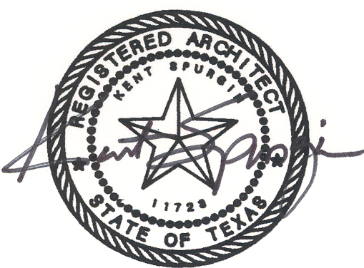
June 26, 2009

AD1, Item 1
Refer to Specification Section 05 12 00 Structural Steel Framing, Pages 05 12 00-2 through 05 12 00-4:
A. Revise Paragraph 2.01 H to read as follows:
“H. Primer (galvanizing touchup): Provide Tneme-Zinc 90-97 as manufactured by Tnemec Co., Inc. or equal products of other manufacturers.”
B. Delete Paragraph 2.03 and all of its subparagraphs in their entirety and insert the following:
“2.03 FINISHES
A. All steel utilized in the stairways and support framing shall have galvanized finish. Galvanizing shall conform to ASTM A123 for zinc (hot-dipped) coating on steel shapes and plates and ASTM A53 for pipe.”
C. After Paragraph 3.02, delete subparagraphs A, B and C in their entirety and add the following paragraph:
“A. Upon completion of installation, touch up field welds and abraded surfaces, using galvanizing touchup primer specified above.”

AD1, Item 2
Refer to Specification Section 05 50 00 Metal Fabrications, Pages 05 50 00-2 through 05 50 00-3:
A. Revise Paragraph 2.02 A to read as follows:
“A. Primer (galvanizing touchup): Provide Tneme-Zinc 90-97 as manufactured by Tnemec Co., Inc. or equal products of other manufacturers.”
B. Add the following new paragraphs:
“2.04 FINISHES
A. All steel utilized in the stairways, support framing, handrails and guardrails shall have galvanized finish. Galvanizing shall conform to ASTM A123 for zinc (hot-dipped) coating on steel shapes and plates and ASTM A53 for pipe.”
C. After Paragraph 3.04, delete subparagraph A and its subparagraph in its entirety and add the following paragraph:
“A. Upon completion of installation, touch up field welds and abraded surfaces, using galvanizing touchup primer specified above.”

AD1, Item 3
Refer to Specification Section 05 51 13 Metal Stairs, Pages 05 51 13-2 through 05 51 13-3:
A. Revise Paragraph 2.01 A 13 to read as follows:
“13. Primer (galvanizing touchup): Provide Tneme-Zinc 90-97 as manufactured by Tnemec Co., Inc. or equal products of other manufacturers.”
B. Delete Paragraph 2.03 C regarding priming in its entirety.
C. Add the following new paragraphs:
“2.04 FINISHES
A. All steel utilized in the stairways, handrails and guardrails shall have galvanized finish. Galvanizing shall conform to ASTM A123 for zinc (hot-dipped) coating on steel shapes and plates and ASTM A53 for pipe.”

AD1, Item 4
Refer to Specification Section 09 91 00 Painting, Pages 09 91 00-1 through 09 91 00-4:
A. In Paragraph 2.01 A 1, delete “Sherwin-Williams Paint Co.” and add “Tnemec Company, Inc., distributed by The Barry Group, LLC, Frisco, Texas, Tel. 972-312-8448, Web www.barrygroup@tnemec.com”.
B. Revise Paragraph 3.03 B 3 as follows:
“3. On galvanized surfaces, provide abrasive blast complying with ASTM D6386 uniformly to provide tooth and anchor or chemically clean per SSPC-SP1 Solvent Cleaning.”
C. Change subparagraph 3.05 B 1 to read “First coat: Touchup galvanizing with Tneme-Zinc 90-97.”
D. Change subparagraph 3.05 B 2 to read “Second coat: Series 27WB Typoxy @ 4-6 mils DFT.”
E. Change subparagraph 3.05 B 3 to read “Third coat: Series 290 CRU Polyurethane @ 2-3 mils DFT.”

AD1, Item 5
MODIFY: Reduce the 1-1/2” OD handrail to 1-1/4” OD.

PLEASE NOTE ALL OTHER TERMS, CONDITIONS, SPECIFICATIONS DRAWINGS, ETC. REMAIN UNCHANGED.
SINCERELY,
FRANKLIN YBARBO
PURCHASING AGENT

