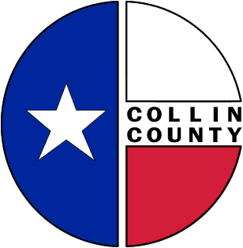 | COLLIN COUNTY | Construction & Projects  4600 Community Ave.  McKinney, Texas 75071  Phone: 972-547-5340  FAX: 972-547-5385

To: Commissioners’ Court
From: Bill Burke/Director of Building Projects
Date: July 1, 2009
Subject: Advertise for Bid: Construction – Courthouse Phase 2

Request Commissioners’ Court consideration and approval to advertise for bid: Construction – Courthouse Phase 2.
Thank you,
Bill Burke
Director of Building Projects

