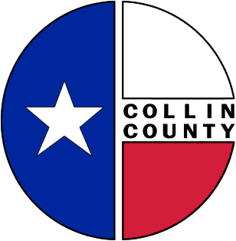
Collin County Memorandum
Date: July 2, 2009
To: Commissioners’ Court
From: Cynthia Jacobson
RE: RFP – Insurance: Long Term Care

Please consider and approve solicitation of proposals for Long Term Care Insurance and advertise for the same.

