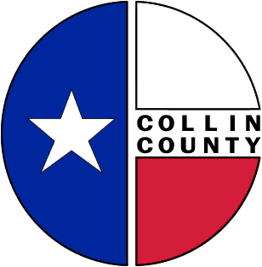
Collin County Memorandum
Date: July 2, 2009
To: Commissioners’ Court
From: Cynthia Jacobson
RE: RFP – Insurance: General Liability and Workers’ Compensation

Please consider and approve solicitation of proposals for General Liability and Workers’ Compensation Insurance and advertise for the same.

