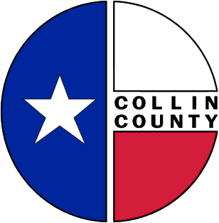 | COLLIN COUNTY | Animal Services  4750 Community Blvd.  McKinney, TX 75071  972-547-7292  www.collincountytx.gov

To: Commissioners’ Court

From: Misty Brown, Animal Services Division Manager

Xc: Bill Bilyeu, Collin County Administrator
Ruben Delgado, Director of Engineering

Date: August 25, 2009

Re: Request to Approve Interlocal Agreement for Animal Shelter/Control Services Contract with the City of Lowry Crossing

We respectfully request that Commissioners' Court approve the Interlocal Agreement for Animal Shelter/Control Services Contract with the City of Lowry Crossing. This agreement provides services starting October 1, 2009 and for a period of 1-year continuing through and including September 30, 2010 and includes renewal terms at a cost to the City of $12,125.00 for Animal Shelter/Control services.

Thank you for your consideration in this matter.

