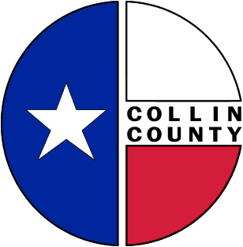 | COLLIN COUNTY | Construction & Projects  4600 Community Ave.  McKinney, Texas 75071  Phone: 972-547-5340  FAX: 972-547-5385

To: Commissioners’ Court
From: Bill Burke/Director of Building Projects
Date: October 9, 2009
Subject: Award – Construction - JJAEP

Request Commissioners’ Court consideration and approval to discuss alternates and award: Construction – Juvenile Justice Alternative Education Program to the lowest and best evaluated bidder, Crossland Construction Company, Inc.
Thank you,
Bill Burke
Director of Building Projects

