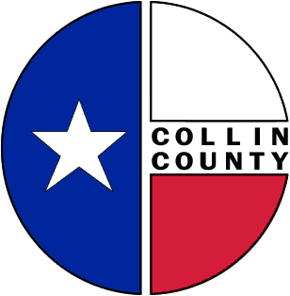 | COLLIN COUNTY | Construction & Projects  4600 Community Ave.  McKinney, Texas 75071  Phone: 972-547-5340  FAX: 972-547-5385

To: Commissioners’ Court
From: Bill Burke/Director of Building Projects
Date: January 7, 2010
Subject: Discussion of Myers Park FY10 PIP Request

Request Commissioners Court discussion and consideration of Myers Park FY10 Permanent Improvement request.

Thank you,
Bill Burke
Director of Building Projects

