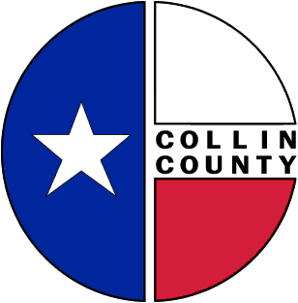 | COLLIN COUNTY | Engineering  825 N. McDonald  Suite 160  McKinney, Texas 75069  972-548-3727  www.collincountytx.gov

January 29, 2010

TO: County Judge and Commissioners

FROM: Ruben Delgado, Director of Engineering

RE: 2007 Parks/Open Space Bond, 1st Series
Project Funding Assistance Program
Interlocal Agreement

Execution of the attached Interlocal Agreement between Collin County and the City of McKinney (Crape Myrtle World Collection Park) is requested. Funding for this project was approved as part of the 2007 Parks/Open Space Bond, 1st Series, Project Funding Assistance Program per Court Order 2009-912-10-26.

cc: Jeff Durham

