

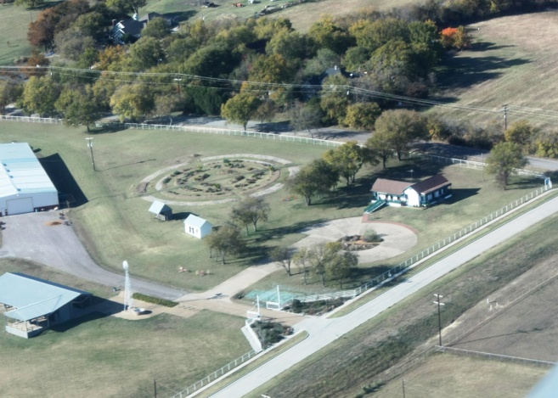

Earth-Kind® Research Program at
Myers Park and Event Center
7117 CR 166, McKinney, Texas 75071

The Earth-Kind® Environmental Stewardship Program uses research-proven techniques to provide maximum garden and landscape enjoyment while preserving and protecting the environment. The objective of Earth-Kind Landscaping is to combine the best of organic and traditional gardening and landscaping principles to create a horticultural system based on real world effectiveness and environmental responsibility. Earth-Kind encourages water conservation, reduction of fertilizer and pesticide use, energy conservation, and reduction of wastes entering landfills.
The Earth Kind Environmental Stewardship Program utilizes the testing of plant material to help achieve the goals of reducing water, pesticide and fertilizer use, while protecting the environment. Texas AgriLife Extension Service and Collin County Master Gardeners have initiated research projects to test different plants in accordance with the principles of the Earth Kind Environmental Stewardship Program.
The goal of this effort is to identify plants with outstanding performance in the landscape and agriculture production, but do not require pesticides and fertilizers, and require only limited or no irrigation. The results of this research program will provide the public with information on plants that will allow them to protect our natural resources, preserve the environment, save money, and reduce their maintenance and inputs.
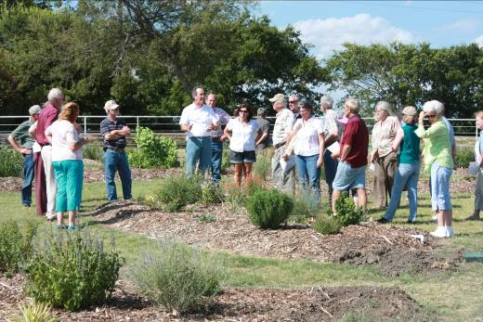
The benefits of the Earth-Kind Research and Demonstration Gardens:
- Provides research based information that allows gardeners, professionals, and producers to become stewards of the environment.
- Provides a source of information on plant performance without the use of pesticide, fertilizers, and irrigation.
- Involves the public in research and demonstration projects.
- Provides a site to conduct educational programs and demonstrate Earth-Kind practices.
- Increases the beauty of parks and open spaces that attracts more visitors.

The first Earth-Kind Perennial Research Garden is located at Myers Park and Event Center. The 8,800 square feet garden is evaluating up to 111 varieties of perennial plants. At Myers Park additional Earth-Kind research efforts are underway, including the testing of crape myrtle, roses, vegetables, and pasture grasses. Earth-Kind Demonstration Gardens, Rain Water Harvesting Demonstration, Drip Irrigation Demonstration, and Demonstration Rain Garden have been installed to educate the public and benefit the park. In the near future, research will be conducted that include herbs, vines, shrubs, groundcover, bulbs, turf grass, fruit trees, nut trees, and wine grapes. Tours of the gardens are available by contacting http://ccmgatx.org/forms/contactus_form.aspx?i=speaker

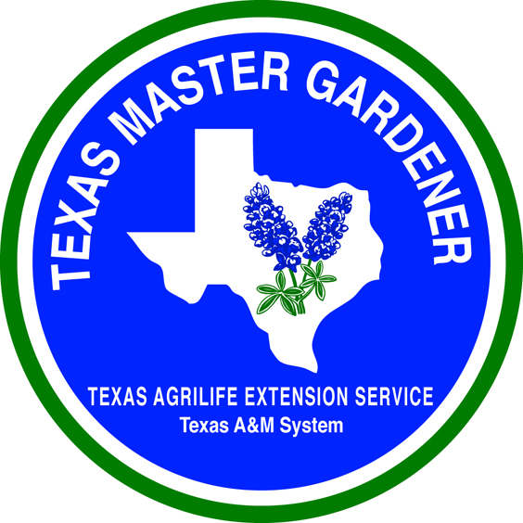


For more information on this research effort contact:
Greg Church, Ph.D., County Extension Agent - Horticulture
Texas AgriLife Extension Service, Texas A&M University System, Collin County
825 N. McDonald Street, Suite 150, McKinney, TX 75069
gtchurch@ag.tamu.edu, http://collincountygardening.tamu.edu, http://ccmgatx.org

